A FILE STORING IN CLOUD FOR ANDROID

ABSTRACT

Over the last few years, there has been a drastic change in information technology. This includes the various ways in which files can be shared and stored. Android OS is a relatively new mobile OS which has been steadily taking over more and more market share. Easy to use, easy to develop for, and open-source, it has picked up a following of developers who want to create content for the masses. Cloud computing is publicized as the next major step for all forms of typical information technology use. From businesses, to non-profit organisations, to single users, there seems to be various applications which can use cloud computing to offer better, faster, and smarter computing. This paper aims to combine the two, building a cloud based application for Android, offering users the power of cloud computing in the palm of their hand.

SYSTEM ARCHITECTURE

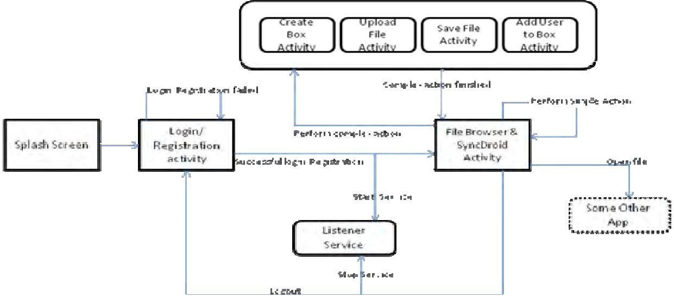

INTRODUCTION

File sharing is the practice of distributing or providing access to digitally stored information, such as computer programs, multimedia (audio, images and video), documents, or electronic books. It may be implemented through a variety of ways.
Android is a relatively new mobile operating system developed by Google and the Open Handset Alliance. [1] Officially released in October 2008, it has revolutionized mobile application development due to the fact that it is open source. It allows developers unparalleled freedoms to create varied and interesting applications. Based on the Java programming language, it is touted as being easy to pick up and master, whilst the underlying is a modified Linux kernel. Some of Android's biggest draws for developers include the relative simplicity of developing using Java syntax, which means quickly producing applications. Also, Android provides easy yet secure access to first and third party applications, allowing deeper integration between components in different programs, and encourages software sharing and reuse. The user interface can be built quickly and simply through XML or graphically, and once an application has been finished it can be submitted to Android market, a portal through which developers can make their creations available to Android users, either free or for profit. [2]

Cloud computing has been viewed in several forms. There has been no single view that has decidedly become the obvious candidate; however there are some common elements between them all. The most glaring of these is that it is a form of distributed computing, in that distinctly separate systems link together to form a cloud. [3] Also, there is an idea of on-the-fly scalability, that machines can join and leave the cloud as required.

One definition of cloud computing is that of a pool of computational resources, linked together to provide a greater processing power. [4] These are projects which involve supporters installing software on computers at home, which connect, when idle, to their respective clouds over the internet and compute small parts of complex scientific calculations. Another use of the term is to provide some form of data syncing.

One more idea of cloud computing is that of peer-to-peer systems. This form has been used for many years for file sharing, recently implemented for services such as Skype. These services reduce load on their servers by passing data directly from user to user.

Java is a general-purpose, concurrent, class-based, object-oriented computer programming language that is specifically designed to have as few implementation dependencies as possible. It is intended to let application developers "write once, run anywhere" (WORA), meaning that code that runs on one platform does not need to be recompiled to run on another. Java applications are typically compiled to bytecode (class file) that can run on any Java virtual machine (JVM) regardless of computer architecture. Java is, as of 2012, one of the most popular programming languages in use, particularly for client-server web applications, with a reported 10 million users. Java was originally developed by James Gosling at Sun Microsystems (which has since merged into Oracle Corporation) and released in 1995 as a core component of Sun Microsystems' Java platform. The language derives much of its syntax from C and C++, but it has fewer low-level facilities than either of them.[5]

The aim of this project is to design and implement a file sharing application for Android based devices. This project will allow multiple users to share files to multiple devices. This project would provide a stable platform to enable collaboration through file sharing. To this end, files may be uploaded by one user and available to another, all simplified through an easy to use application on an Android device.
Existing System

The current generation of open source operating systems is not on IBM mainframes or desktops but now days mostly to carry on the android devices in every day and all places. The simplicity of these new environments has lead to new applications and markets and has enabled greater incorporation . This leads to requirement of more storage capacity, processor speed and smaller sizes. It can be achieved by storing data by the smart phone into the cloud. The client can access the storage files in the cloud environment anywhere in the world through the android without any centralized server and access with high speed broad band internet connections. To start with the user opening application and validates the cloud using the authorizations connected with it through android device. Then the name of the file to be used is specified which forms a uniform resource locater to which the filename is appended. This is then send as an HTTP request to a web server, which in -turn redirects to a cloud application which searches the file name in cloud environment.
Proposed System
he content of the file is send back to android device as http response which is then converted to string and displayed in the android device. The user specifies the filename in the android and the cloud will search the directories for the specified filename. After this, the file will be sent by the cloud to the android. Now through the android, the user can view the contents and do the corresponding updates. By using this application, the pictures can
also be transferred from the android to the cloud. The Android application should be developed in the android device and cloud module has to be maintained in the cloud. By developing Cloud connection module and Android application, the user can access the file anywhere from the world through the android and can also transfer the pictures in the android to the cloud. The flexibility of cloud to provide Software as a Service (SaaS) gives wide opportunities to include offloading in the application. A new framework that automatically offloads heavy back-end tasks of a regular standalone Android application to an Android virtual machine in the cloud is also integrated with the application. applications to the cloud saves energy and extend battery lifetime for android users. Since the actual service is happening in virtual smart phone configured in cloud, the battery backup is more thereby saving the energy.

System Configuration
Requirement analysis is an important activity that takes place before building or changing system. It is done in order to understand the problem and the emphasis is on identifying what is needed from the system and how the system in terms of functional and nonfunctional requirements and serves as contractual base between client and developer.
4.2.1. Hardware Requirements:
Processor : Any Processor above 500 Mhz.
Ram : 128Mb.
Hard Disk : 10 Gb.
Compact Disk : 650 Mb.
Input device : Standard Keyboard and Mouse.
Output device : VGA and High Resolution Monitor.
4.2.2. Software Requirements:
Operating System : Windows XP.
Data Bases : MYSQL, SQLite
Programming : Java and Android

Modules:
- Mobile User
- Select files/upload
- View files
.
1. Mobile User Module:
- User can login and logout.
- Add files to upload
2. Select Files/upload
- Users can select files using android api.
- Can upload files in cloud using ftp api
3. View files
Users can view all uploaded files in cloud.
.
TECHNOLOGIES USED
ANDROID OPERATING SYSTEM
Android is a mobile OS (Operating System ) based on Linux Kernel and currently developed by Google, with a user interface based on direct manipulation. It’s written in c (core), C++, Java. Android is designed primarily for touch screen mobile devices such as smart phones and tablet computers, with specialized user interfaces for television (Android TV), cars (Android Auto) and wrist watches (Android wear). The Operating System uses touch inputs that loosely correspond to real-world actions, like swiping, tapping, pinching and reverse pinching to manipulate on-screen objects and a virtual keyboards.
Despite being primarily designed for touch screen input, it also has been used in games consoles, digital cameras, regular pc’s and other electronics. Android is the most widely used mobile Operating Systems.
The important features are:
a) INTERFACE:
Android defaults uses interface is based on direct manipulation , using touch inputs, that loosely corresponds to real-world actions, like swapping, tapping, pinching and reverse pinching to manipulate onscreen objects and a virtual keyboard.

b) APPLICATION:
Application that extends the functionality of devices are written primarily in the Java programming languages (without the usage “write one, run anywhere” claim of the Java platform) using the Android software development kit (SDK).

c) MEMORY MANAGEMENT:
Since android devices are usually battery-powered, android is designed to manage memory (RAM) to keep power consumption at a minimum, in contact to desk top operating system which generally assumes they are connect to unlimited main electricity.

MOTIVATION OF THE PROJECT:
GPS MONITERING
The main motivation for developing the application is because when our mobile is lost , we usually lodge a complaint in the police station by giving our mobile IMEI number. There is no guarantee that it may be successful. But as by using this app individually a person can trace his mobile by using the Google map navigation. The other features of my app are location monitoring, tracking multiple devices, real-time update, vehicle tracking device.
The GPS tracker converts our smart phone on tablet to GPS tracking device. This quietly records its location (wi-fi on cellular triangulations) periodically and uploads to our secured server. To maintain the location of your tracker device to simply browse to this website using GPS tracker app you can track your family moment daily. In addition you can also locate your lost or stolen device.

Introduction To Java:
Java has been around since 1991, developed by a small team of Sun Microsystems developers in a project originally called the Green project. The intent of the project was to develop a platform-independent software technology that would be used in the consumer electronics industry. The language that the team created was originally called Oak.
The first implementation of Oak was in a PDA-type device called Star Seven (*7) that consisted of the Oak language, an operating system called GreenOS, a user interface, and hardware. The name *7 was derived from the telephone sequence that was used in the team's office and that was dialed in order to answer any ringing telephone from any other phone in the office.
Around the time the First Person project was floundering in consumer electronics, a new craze was gaining momentum in America; the craze was called "Web surfing." The World Wide Web, a name applied to the Internet's millions of linked HTML documents was suddenly becoming popular for use by the masses. The reason for this was the introduction of a graphical Web browser called Mosaic, developed by ncSA. The browser simplified Web browsing by combining text and graphics into a single interface to eliminate the need for users to learn many confusing UNIX and DOS commands. Navigating around the Web was much easier using Mosaic.
It has only been since 1994 that Oak technology has been applied to the Web. In 1994, two Sun developers created the first version of Hot Java, and then called Web Runner, which is a graphical browser for the Web that exists today. The browser was coded entirely in the Oak language, by this time called Java. Soon after, the Java compiler was rewritten in the Java language from its original C code, thus proving that Java could be used effectively as an application language. Sun introduced Java in May 1995 at the Sun World 95 convention.
Web surfing has become an enormously popular practice among millions of computer users. Until Java, however, the content of information on the Internet has been a bland series of HTML documents. Web users are hungry for applications that are interactive, that users can execute no matter what hardware or software platform they are using, and that travel across heterogeneous networks and do not spread viruses to their computers. Java can create such applications.
The Java programming language is a high-level language that can be characterized by all of the following buzzwords:
- Simple
- Architecture neutral
- Object oriented
- Portable
- Distributed
- High performance
- Interpreted
- Multithreaded
- Robust
- Dynamic
- Secure
With most programming languages, you either compile or interpret a program so that you can run it on your computer. The Java programming language is unusual in that a program is both compiled and interpreted. With the compiler, first you translate a program into an intermediate language called Java byte codes —the platform-independent codes interpreted by the interpreter on the Java platform. The interpreter parses and runs each Java byte code instruction on the computer. Compilation happens just once; interpretation occurs each time the program is executed. The following figure illustrates how this works.
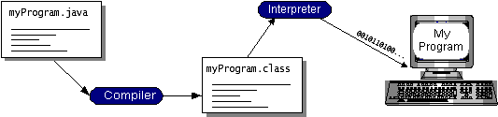
Figure 4.1: Working Of Java
You can think of Java bytecodes as the machine code instructions for the java virtual machine (Java VM). Every Java interpreter, whether it’s a development tool or a Web browser that can run applets, is an implementation of the Java VM. Java bytecodes help make “write once, run anywhere” possible. You can compile your program into bytecodes on any platform that has a Java compiler. The bytecodes can then be run on any implementation of the Java VM. That means that as long as a computer has a Java VM, the same program written in the Java programming language can run on Windows 2000, a Solaris workstation, or on an iMac.
The Java Platform:
A platform is the hardware or software environment in which a program runs. We’ve already mentioned some of the most popular platforms like Windows 2000, Linux, Solaris, and MacOS. Most platforms can be described as a combination of the operating system and hardware. The Java platform differs from most other platforms in that it’s a software-only platform that runs on top of other hardware-based platforms.
The Java platform has two components:
The java virtual mechine (Java VM)
The java application programming interface (Java API)
You’ve already been introduced to the Java VM. It’s the base for the Java platform and is ported onto various hardware-based platforms.
The Java API is a large collection of ready-made software components that provide many useful capabilities, such as graphical user interface (GUI) widgets. The Java API is grouped into libraries of related classes and interfaces; these libraries are known as packages. The next section, What Can Java Technology Do?, highlights what functionality some of the packages in the Java API provide.
The following figure depicts a program that’s running on the Java platform. As the figure shows, the Java API and the virtual machine insulate the program from the hardware.
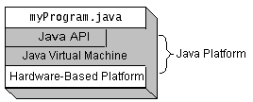
Figure 4.2: The Java Platform
Native code is code that after you compile it, the compiled code runs on a specific hardware platform. As a platform-independent environment, the Java platform can be a bit slower than native code. However, smart compilers, well-tuned interpreters, and just-in-time bytecode compilers can bring performance close to that of native code without threatening portability.
Working Of Java:
For those who are new to object-oriented programming, the concept of a class will be new to you. Simplistically, a class is the definition for a segment of code that can contain both data and functions.When the interpreter executes a class, it looks for a particular method by the name of main, which will sound familiar to C programmers. The main method is passed as a parameter an array of strings (similar to the argv[] of C), and is declared as a static method.
To output text from the program, iexecute the printlnmethod of System. out, which is java’s output stream. UNIX users will appreciate the theory behind such a stream, as it is actually standard output. For those who are instead used to the Wintel platform, it will write the string passed to it to the user’s program.
Swing:
Introduction To Swing:
Swing contains all the components. It’s a big library, but it’s designed to have appropriate complexity for the task at hand – if something is simple, you don’t have to write much code but as you try to do more your code becomes increasingly complex. This means an easy entry point, but you’ve got the power if you need it.
Swing has great depth. This section does not attempt to be comprehensive, but instead introduces the power and simplicity of Swing to get you started using the library. Please be aware that what you see here is intended to be simple. If you need to do more, then Swing can probably give you what you want if you’re willing to do the research by hunting through the online documentation from Sun.
Benefits Of Swing:
Swing components are Beans, so they can be used in any development environment that supports Beans. Swing provides a full set of UI components. For speed, all the components are lightweight and Swing is written entirely in Java for portability.
Swing could be called “orthogonality of use;” that is, once you pick up the general ideas about the library you can apply them everywhere. Primarily because of the Beans naming conventions.
Keyboard navigation is automatic – you can use a Swing application without the mouse, but you don’t have to do any extra programming. Scrolling support is effortless – you simply wrap your component in a JScrollPane as you add it to your form. Other features such as tool tips typically require a single line of code to implement.
Swing also supports something called “pluggable look and feel,” which means that the appearance of the UI can be dynamically changed to suit the expectations of users working under different platforms and operating systems. It’s even possible to invent your own look and feel.
Domain Description:
Data mining involves the use of sophisticated data analysis tools to discover previously unknown, valid patterns and relationships in large data sets. These tools can include statistical models, mathematical algorithms, and machine learning methods (algorithms that improve their performance automatically through experience, such as neural networks or decision trees). Consequently, data mining consists of more than collecting and managing data, it also includes analysis and prediction.
Data mining can be performed on data represented in quantitative, textual, or multimedia forms. Data mining applications can use a variety of parameters to examine the data. They include association (patterns where one event is connected to another event, such as purchasing a pen and purchasing paper), sequence or path analysis (patterns where one event leads to another event, such as the birth of a child and purchasing diapers), classification (identification of new patterns, such as coincidences between duct tape purchases and plastic sheeting purchases), clustering (finding and visually documenting groups of previously unknown facts, such as geographic location and brand preferences), and forecasting (discovering patterns from which one can make reasonable predictions regarding future activities, such as the prediction that people who join an athletic club may take exercise classes)

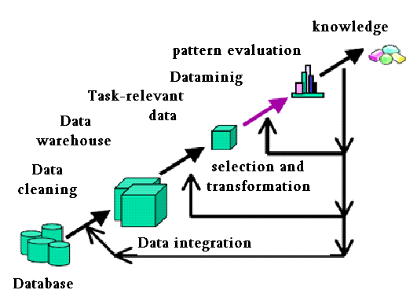

Figure 4.3 knowledge discovery process
Data Mining Uses:
Data mining is used for a variety of purposes in both the private and public sectors.
- Industries such as banking, insurance, medicine, and retailing commonly use data mining to reduce costs, enhance research, and increase sales. For example, the insurance and banking industries use data mining applications to detect fraud and assist in risk assessment (e.g., credit scoring).
- Using customer data collected over several years, companies can develop models that predict whether a customer is a good credit risk, or whether an accident claim may be fraudulent and should be investigated more closely.
The medical community sometimes uses data mining to help predict the effectiveness of a procedure or medicine.
Pharmaceutical firms use data mining of chemical compounds and genetic material to help guide research on new treatments for diseases.
Retailers can use information collected through affinity programs (e.g., shoppers’ club cards, frequent flyer points, contests) to assess the effectiveness of product selection and placement decisions, coupon offers, and which products are often purchased together.

SYSTEM STUDY

FEASIBILITY STUDY

The feasibility of the project is analyzed in this phase and business proposal is put forth with a very general plan for the project and some cost estimates. During system analysis the feasibility study of the proposed system is to be carried out. This is to ensure that the proposed system is not a burden to the company. For feasibility analysis, some understanding of the major requirements for the system is essential.
Three key considerations involved in the feasibility analysis are
ECONOMICAL FEASIBILITY
TECHNICAL FEASIBILITY
SOCIAL FEASIBILITY
ECONOMICAL FEASIBILITY

This study is carried out to check the economic impact that the system will have on the organization. The amount of fund that the company can pour into the research and development of the system is limited. The expenditures must be justified. Thus the developed system as well within the budget and this was achieved because most of the technologies used are freely available. Only the customized products had to be purchased.
TECHNICAL FEASIBILITY

This study is carried out to check the technical feasibility, that is, the technical requirements of the system. Any system developed must not have a high demand on the available technical resources. This will lead to high demands on the available technical resources. This will lead to high demands being placed on the client. The developed system must have a modest requirement, as only minimal or null changes are required for implementing this system.

SOCIAL FEASIBILITY

The aspect of study is to check the level of acceptance of the system by the user. This includes the process of training the user to use the system efficiently. The user must not feel threatened by the system, instead must accept it as a necessity. The level of acceptance by the users solely depends on the methods that are employed to educate the user about the system and to make him familiar with it. His level of confidence must be raised so that he is also able to make some constructive criticism, which is welcomed, as he is the final user of the system.

LITERATURE SURVEY

A rapid Understanding for the cloud computing and control of budgeting,economics and free about very fast accessing in the globally interconnected for distributed network. We can now exploit that power consumption and compute solutions.To survey the cloud computing extremely to change some resolution in the world. The main advantage of cloud computing network to reduce finical, space of development centre and hardware resources. The architecture diagram of the system is given in Fig 1. The application contains two main modules. One is android application installed in smart phone and the second one is cloud application installed in cloud system. The android application is developed using Android SDK. It provides smart phone users, the interface in which user enters the file name and view it. Along with this user can also modify the file and send it back to the cloud. The cloud application gets the input from smart phone to either store it or process it. For file processing in cloud a virtual image of android is set up in the cloud and for storing the data a directory is maintained in the cloud. As an example, in this project face recognition feature has been simulated for demoing offloading. The face recognition logic is set in the cloud space and the result are displayed in android device. This increases the efficiency of the android device by doing by performing the server actions in cloud server based on the request from smartphone the files are transferred to either virtual image or to the directory. The user can also give request through android application to manipulate the files which is already stored in the cloud. The results are displayed back in the android application. Since a virtual image is created in the cloud and all the file processing is happening in the virtual image, the battery backup, processor speed of actual android device is tremendously increased. The application makes all the android data to be stored in to the directory in cloud which makes unlimited storage capacity for android device.
The cloud Environment applications data are accessed millions of Users in multiple devices like android smart phone in your home, The cloud Application server to distribute the data very quickly, undetectable ,virtual memory of cloud environment to solve the problem in physical devices.The application allows user to store the data in a cloud environment and retrieves it and if needed, user can update the file. User interface is designed using android-sdk. User can login to the application with credentials already registered. The credentials are maintained in SQLite Db. Once logged in, the application redirects to search file section, which allows user to enter a filename already there in the cloud and read the file content. The filename entered by the user is appended to an URL which is sends a request to a remote webserver in which turn redirects to the cloud application. The cloud application searches for the filename in the cloud folderand sends its content back to the android application as an HTTP response. The cloud application is a java file which needs to be started before doing the file transfer operation.
Functional and Non-Functional Requirements

- Functoinal Requirements:
Inputs:
a. Server:
In this we will enter ip address for client system. In practice, the mechanism can be executed either by the end-user or by a centralized server. In the former case, the source node is responsible for collecting cost reports from individual SRs and computing the path vector and payments. Such an implementation is suitable for an end-user of sufficient power computation capability. A centralized server implementation is more appropriate for resource-constrained users.
Operation:

Routers are small physical devices that join multiple networks together. Technically, a router is a Layer3 gateway device, meaning that it connects two or more networks and that the router operates at the network layer of the OSI model. This module is used for removing the Hackers among the nodes. This module consists of a textbox field which is used to enter the destination IP address. After that select the node. Now click on start button in server module. With this the data is transferred to the destination through the selected node. To avoid jamming in that node click on particular avoid jammer node. If we want to know the time elapsed for sending the file click on Time elapsed button in Router .Now go to client module there you will get a message saying that file received.Defination of Hackers: a person who illegally gains access to and sometimes tampers with information in a computer system
Output:
By exaggerating its capacity, node may relay a larger fraction of traffic and receive a higher payment, leading to a possibly higher profit. To maintain the overall truthfulness of the mechanism, misreporting of capacity information should be eliminated by design.
- Non Functional Requirements
Performance is measured in terms of the output provided by the application. Requirement specification plays an important part in the analysis of a system. Only when the requirement specifications are properly given, it is possible to design a system, which will fit into required environment. It rests largely in the part of users of the existing system to give the requirement specifications because they are the people who finally use the system.
The requirement specification for any system can be broadly stated as given below:
- The system should be able to interface with the existing system.
- The system should be accurate.
- Te system should be better than existing system.

- Portability: It should run on specified platforms successfully. To achieve this we should test the product on all platforms before launching the product. If our project runs successfully on different platforms then our system is portable in nature.
- Reliability: The system should perform its intended functions under specified conditions. If our system satisfies all the specified conditions then it is Reliable in nature.
- Reusability: The system should be extremely reusable as a whole or part. Make the system modularize and make sure that modules are loosely coupled. This project is having reusability nature because we can reuse whole or part of this project on other systems.
- Robustness: The system on the whole should be robust enough to perform well under different circumstances without any inconsistencies.
- Testability: The product of a given development phase should satisfy the conditions imposed at the start of that phase.
- Usability: It should be perfect and comfortable for users to work.
- Security: The system is completely based on the security. This system will provide security base on the password

DESIGN ANALYSIS
UML Diagrams:
UML is a method for describing the system architecture in detail using the blueprint.
UML represents a collection of best engineering practices that have proven successful in the modeling of large and complex systems.
UML is a very important part of developing objects oriented software and the software development process.
UML uses mostly graphical notations to express the design of software projects.
Using the UML helps project teams communicate, explore potential designs, and validate the architectural design of the software.
Definition:
UML is a general-purpose visual modeling language that is used to specify, visualize, construct, and document the artifacts of the software system.
UML is a language:
It will provide vocabulary and rules for communications and function on conceptual and physical representation. So it is modeling language.
UML Specifying:
Specifying means building models that are precise, unambiguous and complete. In particular, the UML address the specification of all the important analysis, design and implementation decisions that must be made in developing and displaying a software intensive system.
UML Visualization:
The UML includes both graphical and textual representation. It makes easy to visualize the system and for better understanding.

UML Constructing:
UML models can be directly connected to a variety of programming languages and it is sufficiently expressive and free from any ambiguity to permit the direct execution of models.
UML Documenting:
UML provides variety of documents in addition raw executable codes.
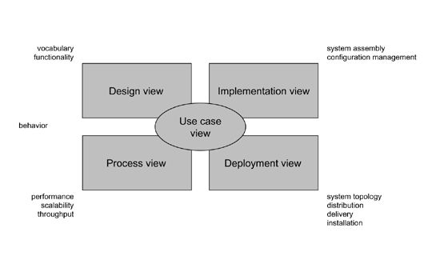
Figure 3.4 Modeling a System Architecture using views of UML

The use case view of a system encompasses the use cases that describe the behavior of the system as seen by its end users, analysts, and testers.
The design view of a system encompasses the classes, interfaces, and collaborations that form the vocabulary of the problem and its solution.
The process view of a system encompasses the threads and processes that form the system's concurrency and synchronization mechanisms.
The implementation view of a system encompasses the components and files that are used to assemble and release the physical system.Thedeployment view of a system encompasses the nodes that form the system's hardware topology on which the system executes.
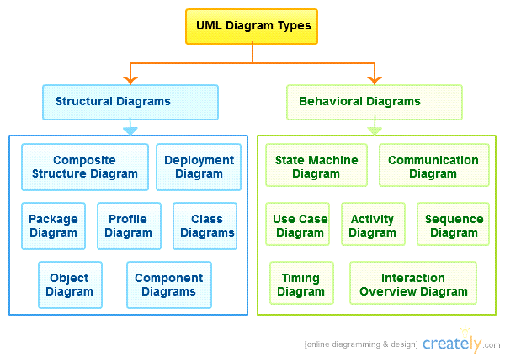
Uses of UML :
The UML is intended primarily for software intensive systems. It has been used effectively for such domain as
Enterprise Information System
Banking and Financial Services
Telecommunications
Transportation
Defense/Aerosp
Retails
Medical Electronics
Scientific Fields
Distributed Web
Building blocks of UML:
The vocabulary of the UML encompasses 3 kinds of building blocks
Things
Relationships
Diagrams
Things:
Things are the data abstractions that are first class citizens in a model. Things are of 4 types
Structural Things, Behavioral Things ,Grouping Things, An notational Things
Relationships:
Relationships tie the things together. Relationships in the UML are
Dependency, Association, Generalization, Specialization
UML Diagrams:
A diagram is the graphical presentation of a set of elements, most often rendered as a connected graph of vertices (things) and arcs (relationships).
There are two types of diagrams, they are:
Structural and Behavioral Diagrams
Structural Diagrams:
The UML‘s four structural diagrams exist to visualize, specify, construct and document the static aspects of a system. ican View the static parts of a system using one of the following diagrams. Structural diagrams consists of Class Diagram, Object Diagram, Component Diagram, Deployment Diagram.
Behavioral Diagrams :
The UML’s five behavioral diagrams are used to visualize, specify, construct, and document the dynamic aspects of a system. The UML’s behavioral diagrams are roughly organized around the major ways which can model the dynamics of a system.
Behavioral diagrams consists of
Use case Diagram, Sequence Diagram, Collaboration Diagram, State chart Diagram, Activity Diagram
Use-Case diagram:
A use case is a set of scenarios that describing an interaction between a user and a system. A use case diagram displays the relationship among actors and use cases. The two main components of a use case diagram are use cases and actors.
An actor is represents a user or another system that will interact with the system you are modeling. A use case is an external view of the system that represents some action the user might perform in order to complete a task.
Contents:
- Use cases
- Actors
- Dependency, Generalization, and association relationships
- System boundary

Browse Dataset

Apply
K-Means

Apply
Hierarchical
Find Comparison

Class Diagram:

Class diagrams are widely used to describe the types of objects in a system and their relationships. Class diagrams model class structure and contents using design elements such as classes, packages and objects. Class diagrams describe three different perspectives when designing a system, conceptual, specification, and implementation. These perspectives become evident as the diagram is created and help solidify the design. Class diagrams are arguably the most used UML diagram type. It is the main building block of any object oriented solution. It shows the classes in a system, attributes and operations of each class and the relationship between each class. In most modeling tools a class has three parts, name at the top, attributes in the middle and operations or methods at the bottom. In large systems with many classes related classes are grouped together to to create class diagrams. Different relationships between diagrams are show by different types of Arrows. Below is a image of a class diagram. Follow the link for more class diagram examples.

Sequence Diagram

Sequence diagrams in UML shows how object interact with each other and the order those interactions occur. It’s important to note that they show the interactions for a particular scenario. The processes are represented vertically and interactions are show as arrows. This article explains thepurpose and the basics of Sequence diagrams.
USER
String Path
String Fname
Double Time
Doubly entrophyval
int kmeansize
Void applykmeans()
Void ApplyHirerical()
Void findentrphy()
Voidfindtimecomp()

State machine diagrams

State machine diagrams are similar to activity diagrams although notations and usage changes a bit. They are sometime known as state diagrams or start chart diagrams as well. These are very useful to describe the behavior of objects that act different according to the state they are at the moment. Below State machine diagram show the basic

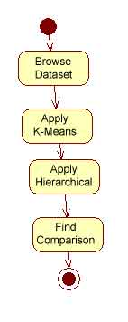

Activity Diagram:

Activity diagrams describe the workflow behavior of a system. Activity diagrams are similar to state diagrams because activities are the state of doing something. The diagrams describe the state of activities by showing the sequence of activities performed. Activity diagrams can show activities that are conditional or parallel.
How to Draw: Activity Diagrams

Activity diagrams show the flow of activities through the system. Diagrams are read from top to bottom and have branches and forks to describe conditions and parallel activities. A fork is used when multiple activities are occurring at the same time. The diagram below shows a fork after activity1. This indicates that both activity2 and activity3 are occurring at the same time. After activity2 there is a branch. The branch describes what activities will take place based on a set of conditions. All branches at some point are followed by a merge to indicate the end of the conditional behavior started by that branch. After the merge all of the parallel activities must be combined by a join before transitioning into the final activity state. .
When to Use: Activity Diagrams

Activity diagrams should be used in conjunction with other modeling techniques such as interaction diagrams and state diagrams. The main reason to use activity diagrams is to model the workflow behind the system being designed. Activity Diagrams are also useful for: analyzing a use case by describing what actions need to take place and when they should occur; describing a complicated sequential algorithm; and modeling applications with parallel processes.

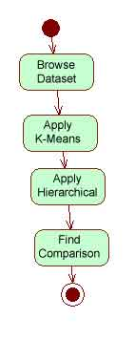

Sample Code

SCREENSHOTS

TESTING
Testing is a process of executing a program with the intent of finding an error. A good test case is one that has a high probability of finding an as-yet –undiscovered error. A successful test is one that uncovers an as-yet- undiscovered error. System testing is the stage of implementation, which is aimed at ensuring that the system works accurately and efficiently as expected before live operation commences. It verifies that the whole set of programs hang together. System testing requires a test consists of several key activities and steps for run program, string, system and is important in adopting a successful new system. This is the last chance to detect and correct errors before the system is installed for user acceptance testing.
The software testing process commences once the program is created and the documentation and related data structures are designed. Software testing is essential for correcting errors. Otherwise the program or the project is not said to be complete. Software testing is the critical element of software quality assurance and represents the ultimate the review of specification design and coding. Testing is the process of executing the program with the intent of finding the error. A good test case design is one that as a probability of finding a yet undiscovered error. A successful test is one that uncovers a yet undiscovered error. Any engineering product can be tested in one of the two ways:
The purpose of testing is to discover errors. Testing is the process of trying to discover every conceivable fault or weakness in a work product. It provides a way to check the functionality of components, sub assemblies, assemblies and/or a finished product It is the process of exercising software with the intent of ensuring that the Software system meets its requirements and user expectations and does not fail in an unacceptable manner. There are various types of test. Each test type addresses a specific testing requirement.

TYPES OF TESTS

Unit testing

Unit testing involves the design of test cases that validate that the internal program logic is functioning properly, and that program inputs produce valid outputs. All decision branches and internal code flow should be validated. It is the testing of individual software units of the application .it is done after the completion of an individual unit before integration. This is a structural testing, that relies on knowledge of its construction and is invasive. Unit tests perform basic tests at component level and test a specific business process, application, and/or system configuration. Unit tests ensure that each unique path of a business process performs accurately to the documented specifications and contains clearly defined inputs and expected results.

Integration testing

Integration tests are designed to test integrated software components to determine if they actually run as one program. Testing is event driven and is more concerned with the basic outcome of screens or fields. Integration tests demonstrate that although the components were individually satisfaction, as shown by successfully unit testing, the combination of components is correct and consistent. Integration testing is specifically aimed at exposing the problems that arise from the combination of components.

Functional test

Functional tests provide systematic demonstrations that functions tested are available as specified by the business and technical requirements, system documentation, and user manuals.
Functional testing is centered on the following items:
Valid Input : identified classes of valid input must be accepted.
Invalid Input : identified classes of invalid input must be rejected.
Functions : identified functions must be exercised.
Output : identified classes of application outputs must be exercised.
Systems/Procedures: interfacing systems or procedures must be invoked.

Organization and preparation of functional tests is focused on requirements, key functions, or special test cases. In addition, systematic coverage pertaining to identify Business process flows; data fields, predefined processes, and successive processes must be considered for testing. Before functional testing is complete, additional tests are identified and the effective value of current tests is determined.

System Test

System testing ensures that the entire integrated software system meets requirements. It tests a configuration to ensure known and predictable results. An example of system testing is the configuration oriented system integration test. System testing is based on process descriptions and flows, emphasizing pre-driven process links and integration points.

White Box Testing

White Box Testing is a testing in which in which the software tester has knowledge of the inner workings, structure and language of the software, or at least its purpose. It is purpose. It is used to test areas that cannot be reached from a black box level.

Black Box Testing

Black Box Testing is testing the software without any knowledge of the inner workings, structure or language of the module being tested. Black box tests, as most other kinds of tests, must be written from a definitive source document, such as specification or requirements document, such as specification or requirements document. It is a testing in which the software under test is treated, as a black box .you cannot “see” into it. The test provides inputs and responds to outputs without considering how the software works.

6.1 Unit Testing:
Unit testing is usually conducted as part of a combined code and unit test phase of the software lifecycle, although it is not uncommon for coding and unit testing to be conducted as two distinct phases.

Test strategy and approach
Field testing will be performed manually and functional tests will be written in detail.

Test objectives
- All field entries must work properly.
- Pages must be activated from the identified link.
- The entry screen, messages and responses must not be delayed.

Features to be tested
- Verify that the entries are of the correct format
- No duplicate entries should be allowed
- All links should take the user to the correct page.

6.2 Integration Testing

Software integration testing is the incremental integration testing of two or more integrated software components on a single platform to produce failures caused by interface defects.
The task of the integration test is to check that components or software applications, e.g. components in a software system or – one step up – software applications at the company level – interact without error.

6.3 Acceptance Testing

User Acceptance Testing is a critical phase of any project and requires significant participation by the end user. It also ensures that the system meets the functional requirements.

Test Results: All the test cases mentioned above passed successfully. No defects encountered.

Test case number | Test case | Input | Expected output | Obtained output
1 | User has to fill all field in registration | Give all fields | Required validations success | Successful registration

Test case number | Test case | Input | Expected output | Obtained output
2 | User has to browse files to upload | Give files fields | Required validations success | Successful upload

CONCLUSION

In this era of multitenant environment emerging complex android application to increases hardware configuration and software solution, there is a high requirement of extensive storage capacity and fast processor for android device which is currently not feasible. Hence the world has to think about other means of distributing the task performed by android device to either system or by some other means which can be accessed through high speed brand band internet through the cloud environment. Cloud provides computational resources that can be used with the help of internet. So user does not have to bother about the maintenance of the resources as it is done by a third party who is providing the cloud services. The usage of cloud for storing the data from android device and performing the task done by android device helps in increasing the computational efficiency of the device. This overcomes the limitation of storage capacity, processor speed and battery life of the android device. The main challenge for storing the data in remote location is the security. The data stored in cloud should be highly secure, so that user oes not loose important information. This challenge has been overcome in the system by maintaining a hash table that has the information about several applications and its genuineness. This revents entry of malicious programs in to the cloud as well as to the android device. A simple trouble shooting required in an operator to validate into thousands of devices access authenticated.

FEATURE DEVELOPMENT

The cloud environment application to reduce the capital expense in hardware and software development. Because to access the software application through network and pay bills, the risks are reduced for uncertainty problems. Cloud environment applications are location independence as long as to access through network. To
increases the flexibility and easily to deploy the model of cloud environment. It’s provide a more security and lesser coast and easily install applications.

References

[1] Stephen A. Ross, Randolph W. Westerfield, Jeffrey Jaffe, Corporate Finance , Fifth Edition.Irwin/McGraw-Hill, 1999, pp. 140–141.
[2] Microsoft Office Help, “IRR,” http://office.microsoft.com/en-us/excel-help/irr-HP005209146.aspx , accessed December 2011.
[3] K.D. Bowers, A. Juels, and A. Oprea, “Hail: A High-Availability and Integrity Layer for Cloud Storage,” Proc. 16th ACM Conf. Computer and Comm. Security,2009.
[4] Q. Wang, K. Ren, W. Lou, and Y. Zhang, “Dependable and Secure Sensor Data Storage with Dynamic Integrity Assurance”, Proc. IEEE INFOCOM, pp. 954-962, 2009.
[5] Q. Wang, C. Wang, J. Li, K. Ren, and W. Lou, “Enabling Public Verifiability and Data Dynamics for Storage Security in Cloud Computing”, Proc.14th European Symp.Research in Computer Security,2009.
[6] Claudio E. Palazzi and Marco Ferrarese, ” FTP4Android: A Local/Remote File Manager for Google Android Platform” 2011.
[7] Yan Ling Jie, Zheng Xiao Yi, Cao Da, Zheng Siting, “Development and Implementation of Eclipse-based File Transfer for Android Smartphone”2012.
[8] Eric Chen1, Satoshi Ogata2, Keitaro Horikawa1” “Offloading Android Applications to the Cloud without Customizing Android”,2012.
[9] Carlota Perez, Technological Revolutions and Financial Capital, The Dynamics ofBubbles and Golden Ages , (Cheltenham, UK: Edward Elgar, 2002), pp. 16–20.
[10] George Reese. Cloud Application Architectures . Sebastapol, CA: O’Reilly Media,Inc. 2009, pp. 52–53.
[11] Caner Kilinc, Todd Booth, and Karl Andersson, “WallDroid: Cloud Assisted Virtualized Application Specific Firewalls for the Android OS “.IEEE 11th International Conference,2012.
[12] G. Marfia, P. Lutterotti, S. Eidenbenz, G. Pau, M. Gerla, “Fair Multi-Media Streaming in Ad Hoc Networks through Local Congestion Control”,2008.
[13] Environmental Leader, “CDP Cloud Computing Can Save $12bn,”www.environmentalleader.com/2011/07/20/cdp-cloud-computing-can-save-12bn ,accessed January 2012.
[14] Cachon, Randall, and Schmidt: “In Search of the Bullwhip Effect,” Manufacturing & ServiceOperations Management 9(4) , pp. 457–479. INFORMS, accessed
January 2012.

